|  |  |  |  |  |
| --- | --- | --- | --- | --- |
|  |  | |  | | --- | | FBLA  August/ September | | 10-18-15 | |
|  |  |  |
| FBla informational table at registration |  | In This Issue |

FBLA would like to send out a big welcome to all of our new members and a welcome back to returning members! Future Business Leaders of America (FBLA) is the largest and oldest business student organization in the world. It consists of over 6,482 chapters in nine countries and over half a million students. FBLA offers students interested in business the opportunity to explore different opportunities there are through meetings, trips, scholarships, and projects. This year meetings will be held the first Wednesday of each month in Ms. Mills’ room. In meetings we will discuss upcoming events, set dates for fundraisers, projects, and events, and discuss new ideas. All members are expected to attend the monthly meetings. Sometimes for special projects we will meet more or an officers meeting will be held. It is crucial that all officers are present during an officers meeting so that everyone has a chance to vote! If you are going to miss a meeting please see Ms. Mills or Tiffany to get caught up on what you missed. Also meeting minutes and calendars can be found online or on the bulletin board to help get what you missed.

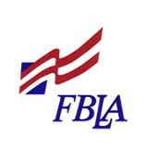

# Welcoming in New Members

by Tiffany Dawson

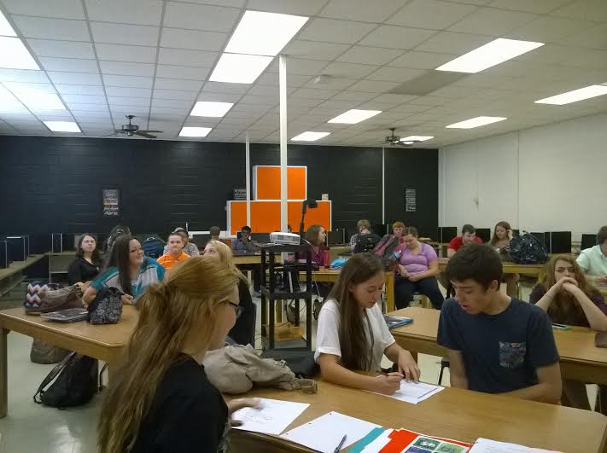

### Inauguration of Officers

On September 9, 2015, ACS FBLA inaugurated in our eleven wonderful officers! In order to obtain their role, officers went through training in a separate meeting. Officers learned about their roles through the Officer Roles PowerPoint, developed leadership skills, assigned to certain tasks, and planned the Program of Works. Officers also voted on new ideas including Honor Chapter, Gold Seal, Lead2Feed, Y Street Grant, and Super Sweeps! Officers include President T. Dawson, Vice-President B. Perdieu, Secretary R. Hogan, Treasurer R. Dalton, Historian H. Roberts, Reporter T. Hall, Parliamentarian Z. Weeks, Community Chair S. Lagos, Social Chair A. Wilson, and Financial Co-Chairs E. Mattox and T. Farmer. During the Inauguration meeting we also voted on the Program of Works and came up with ideas to the Scarecrow Walk. We congratulate all of our officers and look for the best out of ACS FBLA!

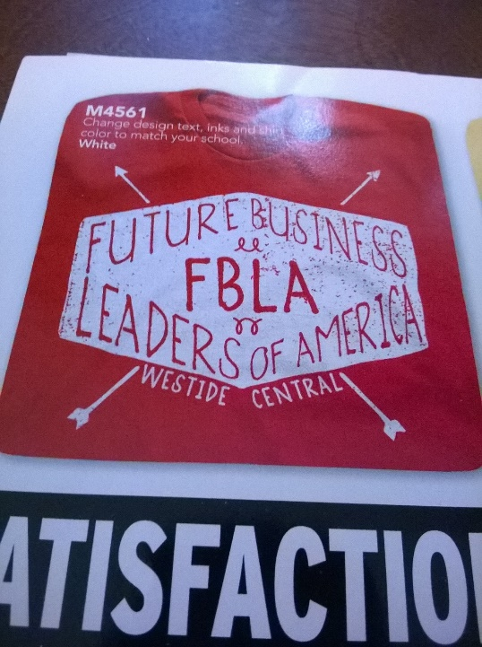

FBLA Officers voted on this year’s t-shirt design to be Future Business Leaders of America with a diamond box around it. T-shirts will be navy blue with light lettering. T-shirts will be in late October. Officers must wear t-shirts to the Longwood officer’s trip. Order your shirt today to show your FBLA pride!

### FBLA 2015-2016 T-Shirts

|  |
| --- |
|  |

Much of August and September was centered on recruiting new members and encouraging old members to rejoin. We kicked off the beginning of August by finishing up and publishing the ACS FBLA website for all to see ([www.altavistafbla.weebly.com](http://www.altavistafbla.weebly.com)). We also focused on setting up a booth outside of Ms. Mills’ room during registration day to answer questions and explain what FBLA is. Throughout the month we hung up posters, created the bulletin board, went on the announcements, and held informational meetings to recruit new members. The goal was to increase membership by ten from last year’s thirty five. Join FBLA to learn more about how we are expanding!

### Recruitment